**Private End Point**

1. Private End Point means you pull the resource into your Vnet & all the traffic stays inside Microsoft backbone Network.
2. Here, I have created a VM, which is by default in a Vnet. And then I created a SQL server, which is not in that Vnet. So now when I try to access that SQL server from the server, it gives error, as the VM cannot take the access of the server. 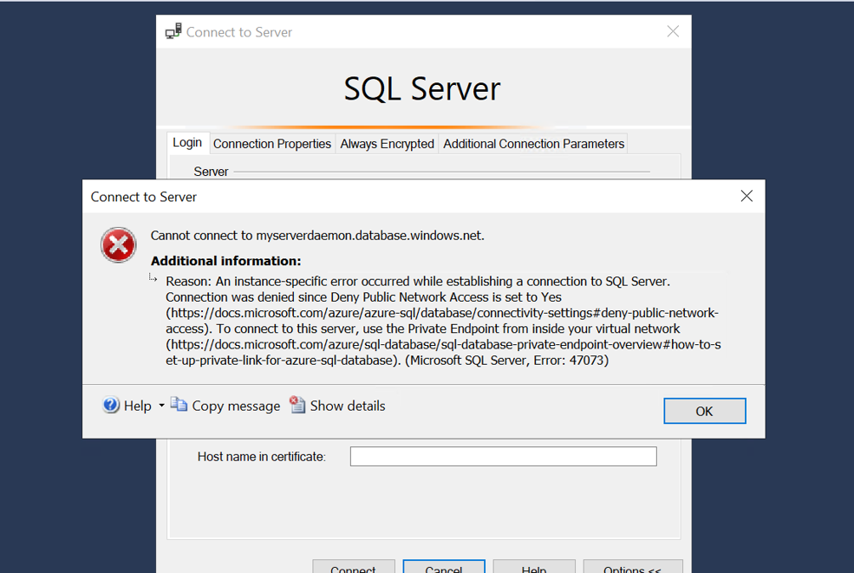
3. Then I went ahead and create a private endpoint in the Server. While creating the private endpoint, the azure automatically creates the DNS zone and required settings. 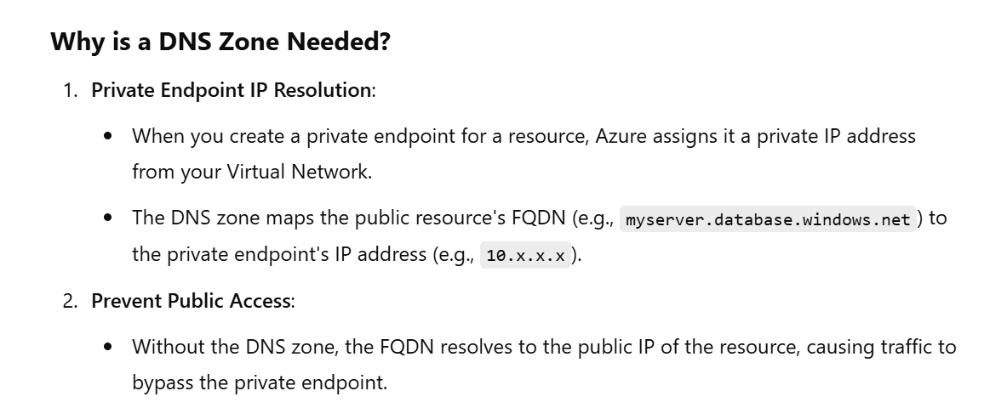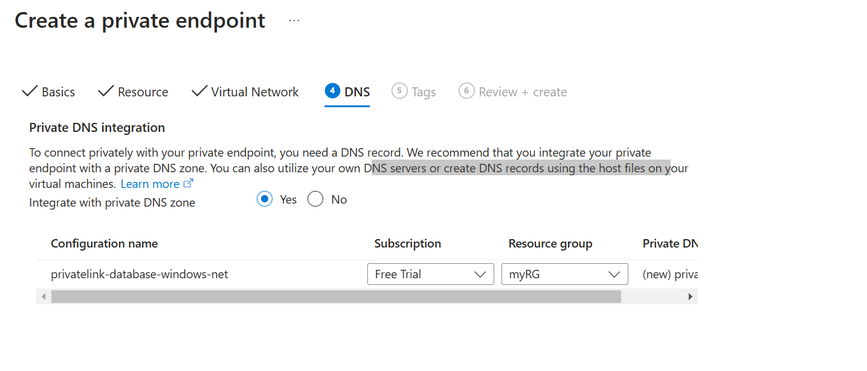
4. Now once the private endpoint has been created then I am able to access the server from the VM. 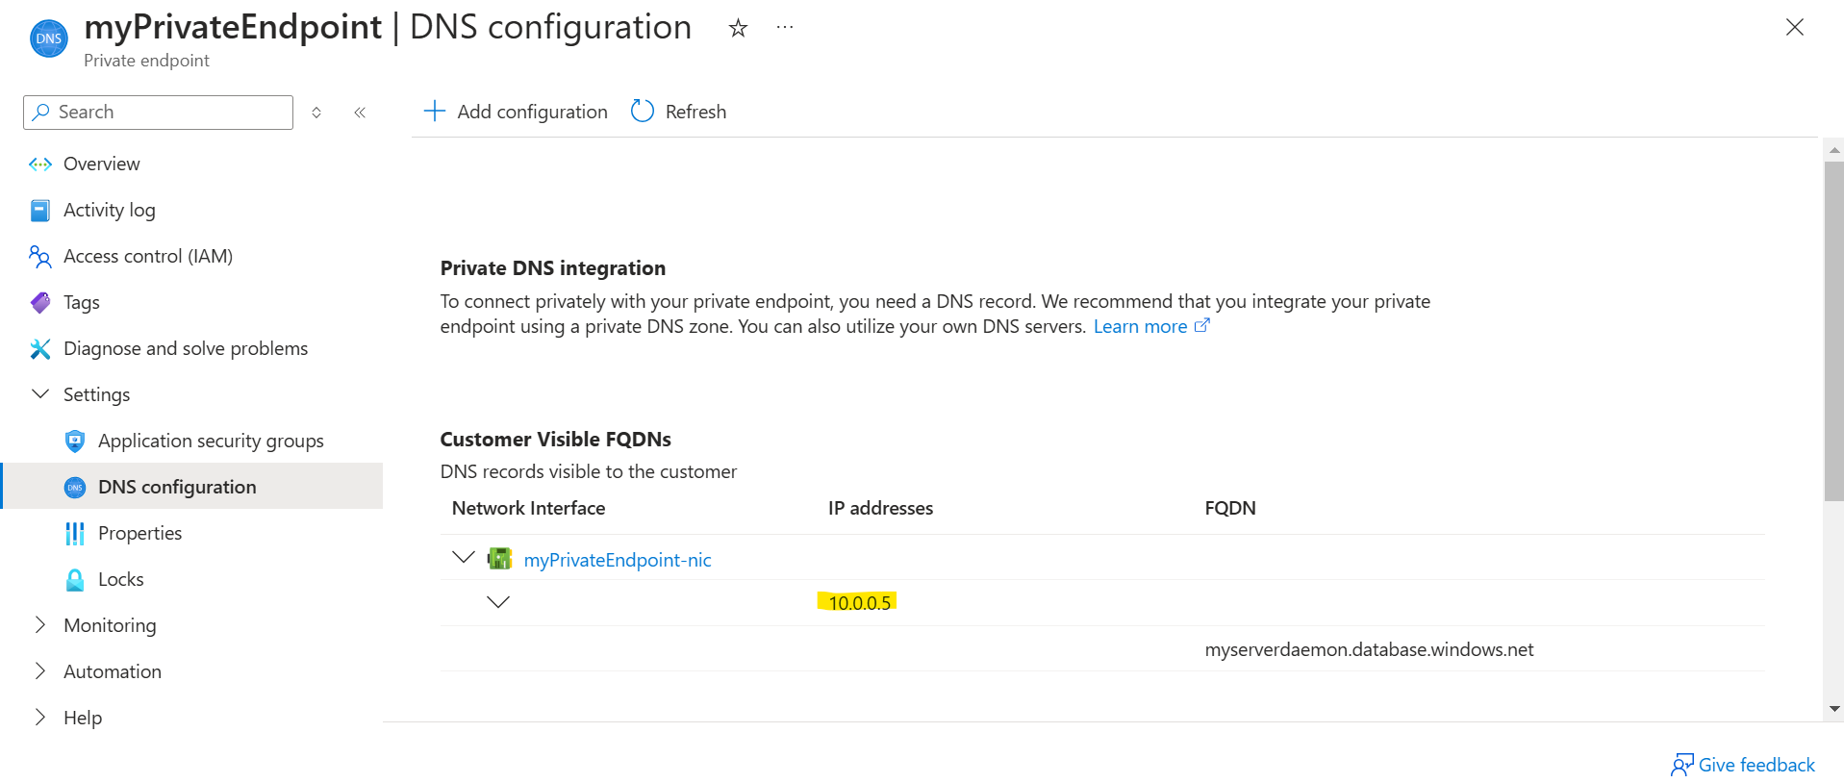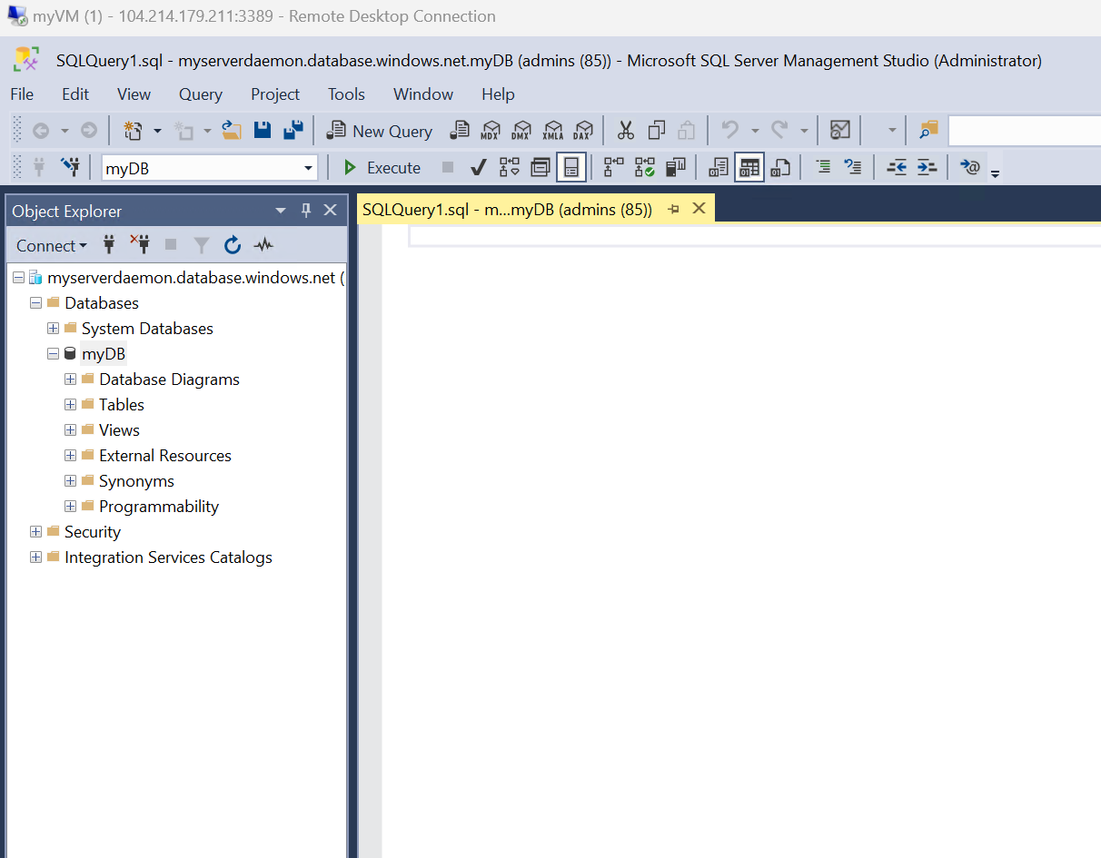
5. Private Endpoint is only helpful if the public access to the DB is not present. To make the DB publicly accessible there is an option as ‘Public Access’ where you can add firewall rule to allow all Ips and then you won’t require Private Endpoint for accessing. But this will expose the DB to the whole world. 